# Tugas Pemrograman Berbasis Objek



**Muhamad Salman Adhim Baqy**

**A11.2020.12641**

**Fakultas Ilmu Komputer**

**Program Studi Teknik Informatika**

**Universitas Dian Nuswantoro**

**2022**

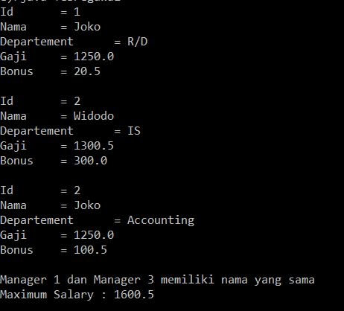

1. Pegawai.java

|  |
| --- |
| public class Pegawai {      private int id;      private String name;      private String departement;      private double gaji;      public Pegawai(){        }      public Pegawai(int id, String name, String departement, double gaji){          // this.id = id;          // this.name = name;          // this.departement = departement;          // this.gaji = gaji;          setId(id);          setName(name);          setDepartement(departement);          setGaji(gaji);      }      public int getId(){          return id;      }      public void setId(int id){          this.id = id;      }      public String getName(){          return name;      }      public void setName(String name){          this.name = name;      }      public String getDepartement(){          return departement;      }      public void setDepartement(String departement){          this.departement = departement;      }      public double getGaji(){          return gaji;      }      public void setGaji(double gaji){          this.gaji = gaji;      }      public void display(){          System.out.println("Id\t = " + id);          System.out.println("Nama\t = " + name);          System.out.println("Departement\t = " + departement);          System.out.println("Gaji\t = " + gaji);      }  } |

1. Manager.java

|  |
| --- |
| public class Manager extends Pegawai{      private double bonus;        public Manager(){      }      public Manager(int id, String name, String departement, double gaji, double bonus){          super(id, name, departement, gaji);          this.bonus = bonus;          //setBonus(bonus);      }      public double getBonus(){          return bonus;      }      public void setBonus(double bonus){          this.bonus = bonus;      }      public double computeSel(){          return getGaji()+bonus;      }          public void accept(int id, String name, String departement, double gaji, double bonus){          setId(id);          setName(name);          setDepartement(departement);          setGaji(gaji);          setBonus(bonus);      }      public void display(){          super.display();          System.out.println("Bonus\t = "+ bonus);      }  } |

1. TesPegawai.java

|  |
| --- |
| public class TesPegawai {      public static boolean isNamaSama(Manager p1, Manager p2){          String namaP1 = p1.getName().toLowerCase();          String namaP2 = p2.getName().toLowerCase();          if(namaP1.equals(namaP2)){              return true;          }else return false;      }      public static double max2(double a, double b){          if(a > b){              return a;          }else return b;      }      public static void main(String[]args) {          Manager e[] = new Manager[3];          e[0] = new Manager();          e[1] = new Manager(2, "Widodo", "IS", 1300.50, 300.00);          e[2] = new Manager(2, "Joko", "Accounting", 1250.00, 100.50);          e[0].accept(1, "Joko", "R/D", 1250.0, 20.5);          //buat loop          for(int i = 0; i <= 2; i++){              e[i].display();System.out.println("");          }          System.out.print("Manager 1 dan Manager 3 memiliki nama yang ");          if(isNamaSama(e[0], e[2])){              System.out.println("sama");          }else System.out.println("tidak sama");          if(e[0].computeSel() > max2(e[1].computeSel(), e[2].computeSel())){              System.out.println("Maximum Salary : "+ e[0].computeSel());          }else if(e[1].computeSel() > max2(e[0].computeSel(), e[2].computeSel())){              System.out.println("Maximum Salary : "+ e[1].computeSel());          }else System.out.println("Maximum Salary : "+ e[2].computeSel());      }  } |